**QUESTION’S.**

1. WRITE A SQL STATEMENT TO DISPLAY THE LOWEST PAID EMPLOYEE'S (NAME , SALARY , DEPARTMENT NAME)

|  |  |  |
| --- | --- | --- |
| **ENAME** | **SAL** | **DNAME** |
| **SMITH** | 800 | RESEARCH |

1. LIST MINIMUM SALARY FOR EACH DEPARTMENT

|  |  |
| --- | --- |
| **DEPTNO** | **MIN(SAL)** |
| **10** | 1300 |
| **20** | 800 |
| **30** | 950 |

1. WRITE A QUERY BASED ON FOLLOWING RESULT.

|  |  |  |  |  |  |
| --- | --- | --- | --- | --- | --- |
| **EMPNO** | **ENAME** | **JOB** | **SAL** | **DEPTNO** | **DNAME** |
| **7369** | SMITH | CLERK | 800 | 20 | RESEARCH |
| **7900** | JAMES | CLERK | 950 | 30 | SALES |
| **7934** | MILLER | CLERK | 1300 | 10 | ACCOUNTING |

1. LIST ALL THE EMPLOYEES WHO ARE WORKING IN FORD’S DEPARTMENT.

|  |  |  |  |  |  |  |
| --- | --- | --- | --- | --- | --- | --- |
| **EMPNO** | **ENAME** | **JOB** | **MGR** | **HIREDATE** | **SAL** | **DEPTNO** |
| **7369** | SMITH | CLERK | 7902 | 17-Dec-00 | 800 | 20 |
| **7566** | JONES | MANAGER | 7839 | 02-Apr-01 | 2975 | 20 |
| **7788** | SCOTT | ANALYST | 7566 | 19-Apr-07 | 3000 | 20 |
| **7876** | ADAMS | CLERK | 7788 | 23-May-07 | 1100 | 20 |
| **7902** | FORD | ANALYST | 7566 | 03-Dec-01 | 3000 | 20 |

1. LIST ALL EMPLOYEE WHO ARE WORKING IN WARD'S DEPARTMENT AND

EARNING MORE THEN MARTIN

|  |  |  |  |  |  |  |
| --- | --- | --- | --- | --- | --- | --- |
| **EMPNO** | **ENAME** | **JOB** | **MGR** | **HIREDATE** | **SAL** | **DEPTNO** |
| **7369** | SMITH | CLERK | 7902 | 17-Dec-00 | 800 | 20 |
| **7566** | JONES | MANAGER | 7839 | 02-Apr-01 | 2975 | 20 |
| **7788** | SCOTT | ANALYST | 7566 | 19-Apr-07 | 3000 | 20 |

1. DISPLAY EMPLOYEE NUMBER, NAME,DEPT NUMBER, DEPT NAME, AND LOCATION

|  |  |  |  |  |
| --- | --- | --- | --- | --- |
| **EMPNO** | **ENAME** | **DEPTNO** | **DNAME** | **LOC** |
| **7369** | SMITH | 20 | RESEARCH | DALLAS |
| **7499** | ALLEN | 30 | SALES | CHICAGO |
| **7521** | WARD | 30 | SALES | CHICAGO |
| **7566** | JONES | 20 | RESEARCH | DALLAS |
| **7654** | MARTIN | 30 | SALES | CHICAGO |
| **7698** | BLAKE | 30 | SALES | CHICAGO |
| **7782** | CLARK | 10 | ACCOUNTING | NEW YORK |
| **7788** | SCOTT | 20 | RESEARCH | DALLAS |
| **7839** | KING | 10 | ACCOUNTING | NEW YORK |
| **7844** | TURNER | 30 | SALES | CHICAGO |
| **7876** | ADAMS | 20 | RESEARCH | DALLAS |
| **7900** | JAMES | 30 | SALES | CHICAGO |
| **7902** | FORD | 20 | RESEARCH | DALLAS |
| **7934** | MILLER | 10 | ACCOUNTING | NEW YORK |

1. DISPLAY THE FOLLOWING RESULT

|  |  |  |
| --- | --- | --- |
| **DEPTNO** | **DNAME** | **ENAME** |
| **10** | ACCOUNTING | CLARK |
| **10** | ACCOUNTING | KING |
| **10** | ACCOUNTING | MILLER |
| **20** | RESEARCH | JONES |
| **20** | RESEARCH | FORD |
| **20** | RESEARCH | ADAMS |
| **20** | RESEARCH | SMITH |
| **20** | RESEARCH | SCOTT |
| **30** | SALES | WARD |
| **30** | SALES | TURNER |
| **30** | SALES | ALLEN |
| **30** | SALES | JAMES |
| **30** | SALES | BLAKE |
| **30** | SALES | MARTIN |

1. LIST ALL THE EMPLOYEE WHO ARE WORKING IN NEW YORK

|  |  |  |  |
| --- | --- | --- | --- |
| **ENAME** | **DEPTNO** | **DNAME** | **LOC** |
| **CLARK** | 10 | ACCOUNTING | NEW YORK |
| **KING** | 10 | ACCOUNTING | NEW YORK |
| **MILLER** | 10 | ACCOUNTING | NEW YORK |

1. WRITE A SQL STATEMENT TO DISPLAY THE LOWEST PAID EMPLOYEE'S (NAME , SALARY , DEPARTMENT NAME) IN THE RESPECTIVE DEPARTMENT.

|  |  |  |
| --- | --- | --- |
| **ENAME** | **MIN(SAL)** | **DNAME** |
| **SMITH** | 800 | RESEARCH |
| **JAMES** | 950 | SALES |
| **MILLER** | 1300 | ACCOUNTING |

1. WRITE A SQL STATEMENT TO DISPLAY THE HIGHEST PAID EMPLOYEE'S (NAME, JOB, MANAGER NAME, SALARY AND DEPARTMENT NAME AND DEPARTMENT NO.) IN THE RESPECTIVE DEPARTMENT.

|  |  |  |  |  |
| --- | --- | --- | --- | --- |
| **EMPNO** | **JOB** | **MGR** | **MAX(SAL)** | **DNAME** |
| **7698** | MANAGER | 7839 | 2850 | SALES |
| **7788** | ANALYST | 7566 | 3000 | RESEARCH |
| **7839** | PRESIDENT |  | 5000 | ACCOUNTING |
| **7902** | ANALYST | 7566 | 3000 | RESEARCH |

1. WRITE A SQL STATEMENT TO DISPLAY THE EMPLOYEE NAME (BOSS) AND NUMBER OF EMPLOYEE (SUBORDINATES) DIRECTLY REPORTING TO HIM?

|  |  |
| --- | --- |
| **BOSS** | **SUBORDINATES** |
| **JONES** | 2 |
| **FORD** | 1 |
| **CLARK** | 1 |
| **SCOTT** | 1 |
| **BLAKE** | 5 |
| **KING** | 3 |

1. DISPLAY THE NAMES, DESIGNATION AND SALARIES OF ALL EMPLOYEES WHO HAVE MANAGER ALONG WITH MANAGER'S NAME, DESIGNATION AND MANAGER'S SALARY.

(SELF-JOIN)

1. Create the following tables:

ORDER: {Id, OrderDate, OrderNumber}

ORDER_ITEM: {Id, OrderId, ProductId, UnitPrice, Quantity}

PRODUCT: {Id, ProductName}

Write a query to display the following output sorted by order no:

|  |  |  |  |  |
| --- | --- | --- | --- | --- |
| **ORDER_NO** | **ORDER_DATE** | **PRODUCT_NAME** | **QUANTITY** | **UNIT_PRICE** |
| **7369** | 7/4/2012 12:00:00 AM | EASY-TRADING | 800 | 20 |
| **7900** | 2/10/2011 12:00:00 AM | BANK-ANYWHERE | 950 | 30 |
| **7934** | 9/23/2015 12:00:00 AM | TRIP-MANAGER | 1300 | 10 |

1. Find the 2nd minimum salary of the employee.
2. Find the max 3 salaries from employee table.
3. Display common records from emp_1 & emp_2 tables. (Use INTERSECT)
4. Display department no wise total salary where more than 2 employees exist in a department.

**ANSWER.**

1. WRITE A SQL STATEMENT TO DISPLAY THE LOWEST PAID EMPLOYEE'S (NAME , SALARY , DEPARTMENT NAME)

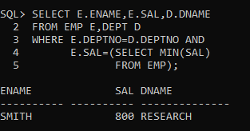

1. LIST MINIMUM SALARY FOR EACH DEPARTMENT

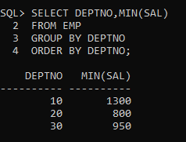

1. WRITE A QUERY BASED ON FOLLOWING RESULT.

|  |  |  |  |  |  |
| --- | --- | --- | --- | --- | --- |
| **EMPNO** | **ENAME** | **JOB** | **SAL** | **DEPTNO** | **DNAME** |
| **7369** | SMITH | CLERK | 800 | 20 | RESEARCH |
| **7900** | JAMES | CLERK | 950 | 30 | SALES |
| **7934** | MILLER | CLERK | 1300 | 10 | ACCOUNTING |

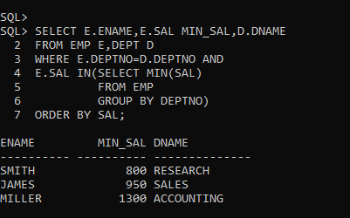

1. LIST ALL THE EMPLOYEES WHO ARE WORKING IN FORD’S DEPARTMENT.

|  |  |  |  |  |  |  |
| --- | --- | --- | --- | --- | --- | --- |
| **EMPNO** | **ENAME** | **JOB** | **MGR** | **HIREDATE** | **SAL** | **DEPTNO** |
| **7369** | SMITH | CLERK | 7902 | 17-Dec-00 | 800 | 20 |
| **7566** | JONES | MANAGER | 7839 | 02-Apr-01 | 2975 | 20 |
| **7788** | SCOTT | ANALYST | 7566 | 19-Apr-07 | 3000 | 20 |
| **7876** | ADAMS | CLERK | 7788 | 23-May-07 | 1100 | 20 |
| **7902** | FORD | ANALYST | 7566 | 03-Dec-01 | 3000 | 20 |

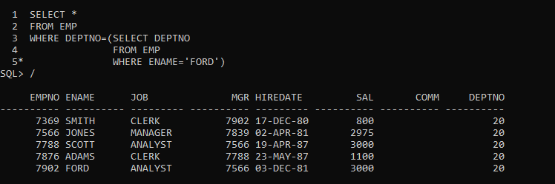

1. LIST ALL EMPLOYEE WHO ARE WORKING IN WARD'S DEPARTMENT AND

EARNING MORE THEN MARTIN

|  |  |  |  |  |  |  |
| --- | --- | --- | --- | --- | --- | --- |
| **EMPNO** | **ENAME** | **JOB** | **MGR** | **HIREDATE** | **SAL** | **DEPTNO** |
| **7369** | SMITH | CLERK | 7902 | 17-Dec-00 | 800 | 20 |
| **7566** | JONES | MANAGER | 7839 | 02-Apr-01 | 2975 | 20 |
| **7788** | SCOTT | ANALYST | 7566 | 19-Apr-07 | 3000 | 20 |

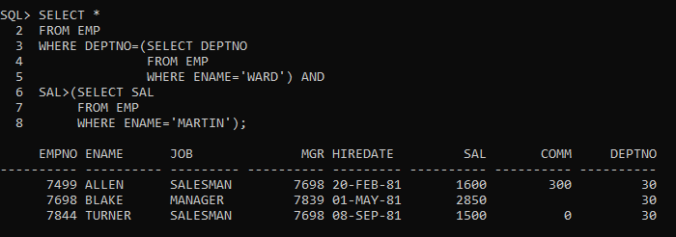

1. DISPLAY EMPLOYEE NUMBER, NAME,DEPT NUMBER, DEPT NAME, AND LOCATION

|  |  |  |  |  |
| --- | --- | --- | --- | --- |
| **EMPNO** | **ENAME** | **DEPTNO** | **DNAME** | **LOC** |
| **7369** | SMITH | 20 | RESEARCH | DALLAS |
| **7499** | ALLEN | 30 | SALES | CHICAGO |
| **7521** | WARD | 30 | SALES | CHICAGO |
| **7566** | JONES | 20 | RESEARCH | DALLAS |
| **7654** | MARTIN | 30 | SALES | CHICAGO |
| **7698** | BLAKE | 30 | SALES | CHICAGO |
| **7782** | CLARK | 10 | ACCOUNTING | NEW YORK |
| **7788** | SCOTT | 20 | RESEARCH | DALLAS |
| **7839** | KING | 10 | ACCOUNTING | NEW YORK |
| **7844** | TURNER | 30 | SALES | CHICAGO |
| **7876** | ADAMS | 20 | RESEARCH | DALLAS |
| **7900** | JAMES | 30 | SALES | CHICAGO |
| **7902** | FORD | 20 | RESEARCH | DALLAS |
| **7934** | MILLER | 10 | ACCOUNTING | NEW YORK |

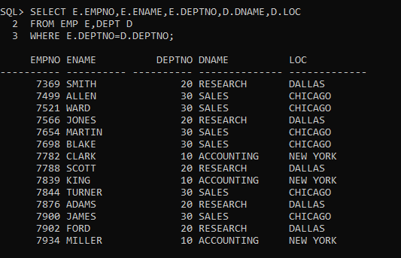

1. DISPLAY THE FOLLOWING RESULT

|  |  |  |
| --- | --- | --- |
| **DEPTNO** | **DNAME** | **ENAME** |
| **10** | ACCOUNTING | CLARK |
| **10** | ACCOUNTING | KING |
| **10** | ACCOUNTING | MILLER |
| **20** | RESEARCH | JONES |
| **20** | RESEARCH | FORD |
| **20** | RESEARCH | ADAMS |
| **20** | RESEARCH | SMITH |
| **20** | RESEARCH | SCOTT |
| **30** | SALES | WARD |
| **30** | SALES | TURNER |
| **30** | SALES | ALLEN |
| **30** | SALES | JAMES |
| **30** | SALES | BLAKE |
| **30** | SALES | MARTIN |

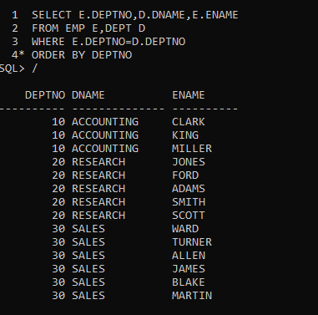

1. LIST ALL THE EMPLOYEE WHO ARE WORKING IN NEW YORK

|  |  |  |  |
| --- | --- | --- | --- |
| **ENAME** | **DEPTNO** | **DNAME** | **LOC** |
| **CLARK** | 10 | ACCOUNTING | NEW YORK |
| **KING** | 10 | ACCOUNTING | NEW YORK |
| **MILLER** | 10 | ACCOUNTING | NEW YORK |
|  |  |  |  |

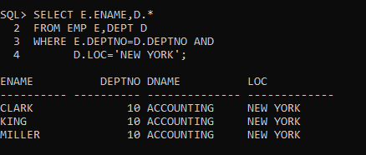

1. WRITE A SQL STATEMENT TO DISPLAY THE LOWEST PAID EMPLOYEE'S (NAME , SALARY , DEPARTMENT NAME) IN THE RESPECTIVE DEPARTMENT.

|  |  |  |
| --- | --- | --- |
| **ENAME** | **MIN(SAL)** | **DNAME** |
| **SMITH** | 800 | RESEARCH |
| **JAMES** | 950 | SALES |
| **MILLER** | 1300 | ACCOUNTING |

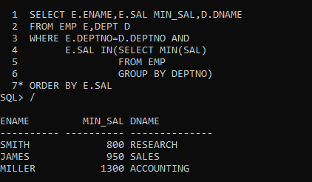

1. WRITE A SQL STATEMENT TO DISPLAY THE HIGHEST PAID EMPLOYEE'S (NAME, JOB, MANAGER NAME, SALARY AND DEPARTMENT NAME AND DEPARTMENT NO.) IN THE RESPECTIVE DEPARTMENT.

|  |  |  |  |  |
| --- | --- | --- | --- | --- |
| **EMPNO** | **JOB** | **MGR** | **MAX(SAL)** | **DNAME** |
| **7698** | MANAGER | 7839 | 2850 | SALES |
| **7788** | ANALYST | 7566 | 3000 | RESEARCH |
| **7839** | PRESIDENT |  | 5000 | ACCOUNTING |
| **7902** | ANALYST | 7566 | 3000 | RESEARCH |

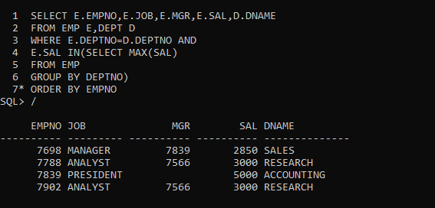



1. WRITE A SQL STATEMENT TO DISPLAY THE EMPLOYEE NAME (BOSS) AND NUMBER OF EMPLOYEE (SUBORDINATES) DIRECTLY REPORTING TO HIM?

|  |  |
| --- | --- |
| **BOSS** | **SUBORDINATES** |
| **JONES** | 2 |
| **FORD** | 1 |
| **CLARK** | 1 |
| **SCOTT** | 1 |
| **BLAKE** | 5 |
| **KING** | 3 |

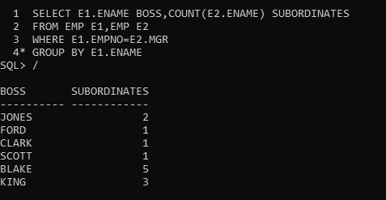

1. DISPLAY THE NAMES, DESIGNATION AND SALARIES OF ALL EMPLOYEES WHO HAVE MANAGER ALONG WITH MANAGER'S NAME, DESIGNATION AND MANAGER'S SALARY.

(SELF-JOIN)

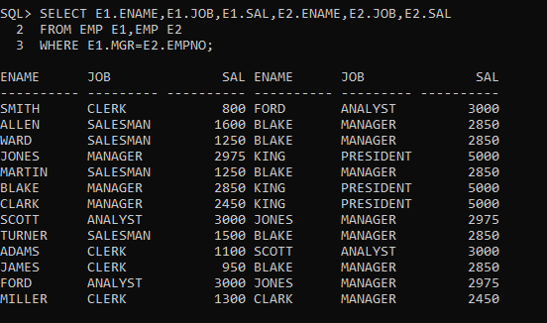

1. Create the following tables:

ORDER: {Id, OrderDate, OrderNumber}

ORDER_ITEM: {Id, OrderId, ProductId, UnitPrice, Quantity}

PRODUCT: {Id, ProductName}

Write a query to display the following output sorted by order no:

|  |  |  |  |  |
| --- | --- | --- | --- | --- |
| **ORDER_NO** | **ORDER_DATE** | **PRODUCT_NAME** | **QUANTITY** | **UNIT_PRICE** |
| **7369** | 7/4/2012 12:00:00 AM | EASY-TRADING | 800 | 20 |
| **7900** | 2/10/2011 12:00:00 AM | BANK-ANYWHERE | 950 | 30 |
| **7934** | 9/23/2015 12:00:00 AM | TRIP-MANAGER | 1300 | 10 |

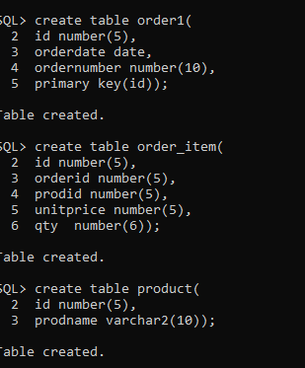

**DISPLAY TABLE**

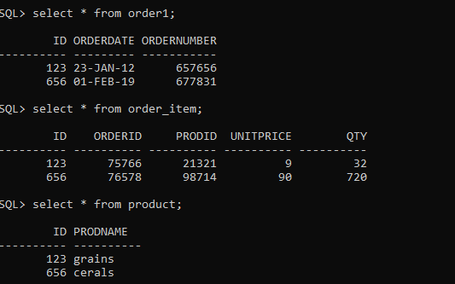

**QUERY**



1. Find the 2nd minimum salary of the employee.

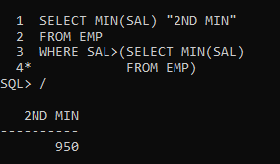

1. Find the max 3 salaries from employee table.

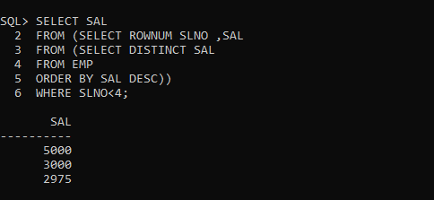

1. Display common records from emp_1 & emp_2 tables. (Use INTERSECT)

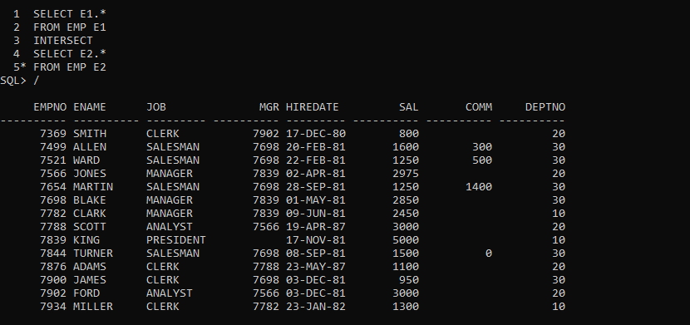

17)Display department no wise total salary where more than 2 employees exist in a department.

